

Welcome to the 2022-2023 School Year
Lincoln Elementary
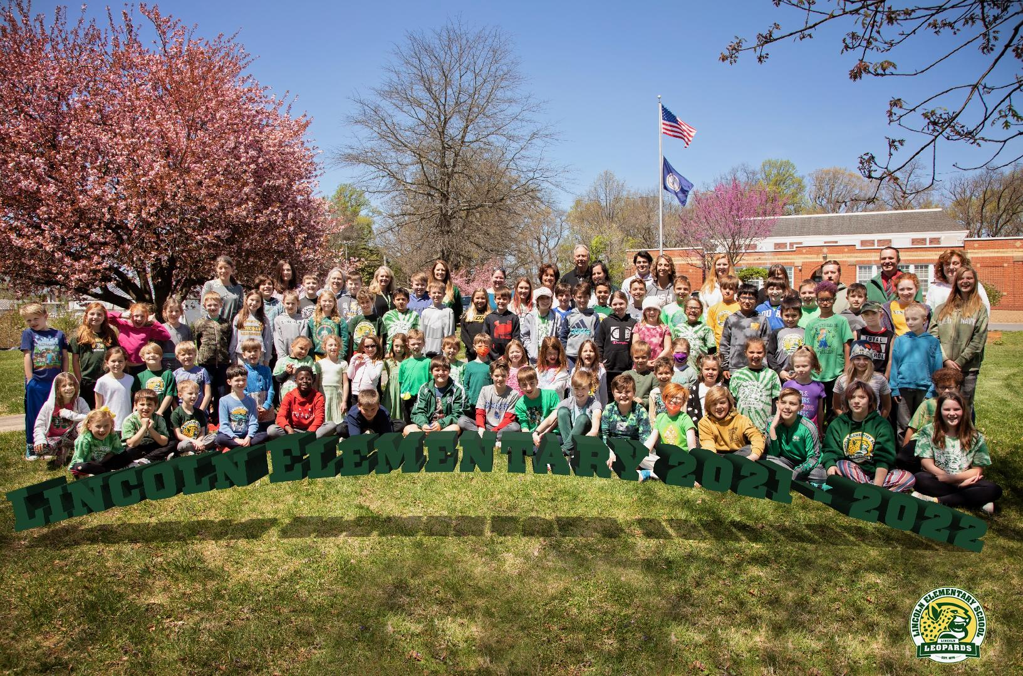

Welcome!
This newsletter provides an introduction to Lincoln Elementary’s Parent Teacher Organization (PTO), including what the PTO is, what we do, how you can help, and most importantly, what tool the PTO and room parents use for communication with the school and classes.

What is the Lincoln PTO?
The PTO’s goals are to encourage interaction between family and school, serve as a source of support, and work with teachers, staff, and the community at large to improve our children's educational experience. The PTO works closely with the teachers to provide enhanced school experiences during school hours. The PTO coordinates numerous after school enrichment opportunities as well.
All parents are members of the PTO just by being a parent at Lincoln. PTO meetings are once a month, and all are encouraged to come anytime. There are no dues to join, and everyone’s participation is welcome!
Mark your calendars: For the fall of 2022, we will continue with virtual PTO meetings on the 2nd Monday of the month from 7-8 pm. We will have 2 exceptions to this due to a school holiday- in October and March, we will meet on the 1st Monday of the month. We will have a link available to sign in from your child’s Chromebook or Google Meet and reminders will be sent out before the meeting.
As always, if there are any questions, please reach out to any board member or email us at: ptolincolnes@gmail.com

Communications - PTBoard
PTBoard is a PTO communication and administrative board, which aids in communication of PTO events and activities throughout the school year. The school directory will be located on this board as well. You can find our school’s PTBoard at lincoln.ptboard.com. All parents who already have a PTBoard account will need to re-sign in with their login information and update any information. For all NEW parents/staff (and those who haven’t used PTBoard in a long time), a link will be sent out by Mr. Michener with instructions, or you can set up your account, by following the steps below:
1. Parents or school members browse to lincoln.ptboard.com
2. Click > Sign Up
3. Fill out Sign In information
4. On "Join School" pop-up screen, enter your school code MKCGPW
5. Please navigate to “Forms and Payments”> “Free Membership & School Directory for the Year”, then click the link for the current school year to fill out all your student and parent information. This also allows you to “opt out” of your information showing in the directory if you so choose.
6. Be sure to click “Add to Cart” then “Check out” and “Submit”. (Again, this is FREE.)
7. The PTO will be notified that you have signed up and “approve” your membership.
a. Once this is done, you will be able to access the site completely
8. This process needs to be done annually.
OR you can use a QR Code as shown below:
Parent Signup Instructions
- Go to https://lincoln.ptboard.com or scan below QR code

- Click "Sign Up" link to sign up (For mobile phone, click top right menu, then "Sign Up" link)
- After signing in to https://lincoln.ptboard.com, enter code MKCGPW to join
Calendar of Events
In a typical school year, there are many activities planned throughout the year. The attached calendar is an overview of what we may expect over the next school year. “LES” denotes a Lincoln Elementary-sponsored event and “PTO” denotes a PTO-sponsored event. This is an overview, and some dates may change. Key to calendar:

Lincoln Elementary/PTO Calendar
Month | Day | Event | LES or PTO Event
August | 23 | Back to School Night (6:30 pm) *Parents Only | LES
August | 24 | Orientation for kids: 1 pm; open house style  Kindergarten kids only: bus ride 1 pm | LES
August | 25 | First Day of School
September | 2 | No School
September | 5 | No School
September | 7 | Spirit Wear orders are due | ALL
September | 9 | Joe Corbi orders are due | ALL
September | 9 | Charcuterie Class at Walsh Family Winery | ALL
September | 12 | Patriots Day- Purcellville FD will raise the flag this morning and lead the Pledge of Allegiance. All are encouraged to wear red, white and blue today. | LES
September | 12 | Grandparent or Special Person can come to lunch | LES
September | 12 | Virtual PTO meeting 7-8 pm | ALL
September | 15 | School Potluck and BINGO 6-7:30 pm | PTO/LES
September | 22 | Community Service: JK Community Farm 330-430 after school at the farm | LES
September | 26 | No School- County Wide Staff Development
October | 3 | Virtual PTO Meeting 7-8 pm ** please note change in schedule**
October | 5 | No School - Yom Kippur
October | 10 | No School - Indigenous Peoples’ Day
October | 10 | Bowling at the Branch in Leesburg 5-10 pm
October | 13 | Original Artwork is due | PTO/LES
October | 21 | Donuts for Dad or that special person | PTO/LES
October | 24 | No School - Diwali
October | 27 | Fall Festival | PTO
October | 28 | *Fall Festival Back Up Day*
October | 31 | No School - Planning Day
November | 1 | No School - Planning Day
November | 4 | Lifetouch Picture Day | LES
November | 4 | Elysium Axe Throwing | ADULTS ONLY
November | 8 | No School - Election Day
November | 11 | Veterans Day | LES
November | 14 | Virtual PTO Meeting 7-8 pm
November | 19 | Holiday Bazaar/Craft Fair 8 am – 12 noon
November | 23-27 | No School - Thanksgiving Break
December | 6 | Community Service: JK Community Farm will come to the school | LES
December | 8 | Cookies / Photos with Santa | PTO
December | 12 | Virtual PTO Meeting 7-8 pm | ALL
December | 15 | Tree of Life (TOL) Dinner
December | 17 | Start of Winter Break
January | 3 | School resumes
January | 9 | Virtual PTO Meeting 7-8 pm
January | 16 | No School - Martin Luther King Jr. Day
January | 18 | Family Game Night & Desserts | LES
January | 23 | No School - Lunar New Year
January | 24 | No School - Moveable Planning Day
January -February | 1/13-2/24 | Read-a-Thon | PTO
February | 13 | Virtual PTO Meeting 7-8 pm
February | 16 | Tree of Life (TOL) Dinner
February | 20 | No School - Presidents’ Day
March | 6 | Virtual PTO Meeting 7-8 pm **schedule change due to holiday**
March | 9 | Mt. Vernon School-wide Field Trip
March | 13 | No School - County-Wide Staff Development
March | 19-20 | School Beautification Weekend | LES/PTO
March | 27 | No School – Planning Day
March | 29 | Science Fair | LES
April | 3-9 | Spring Break, school resumes on Monday, April 10th
April | 10 | Virtual PTO Meeting 7-8 pm | ALL
April | 13 | Tree of Life (TOL) Dinner | ALL
April | 20 | Earth Day | PTO
April | 21 | No School - Eid al Fitr
May | 1-5 | Teacher Appreciation Week | PTO
May | TBD | Talent Show (Place Holder)
May | 8 | Last Virtual PTO Meeting of School Year 7-8 pm | Voting is here
May | 12 | Muffins for Mom or that special person | PTO/LES
May | 29 | No School - Memorial Day
June | 1 | Field Day | LES
June | 2 | *Field Day Alternate Date* | LES
June | 8 | Last Day of School
Color Codes: |  | Blue: School Events (LES)
 |  | PTO Sponsored Events
 |  | Community Service Events
 |  | PTO Meetings
 |  | PTO Fundraising Events
 |  | School Holidays | 1st and Last Day of School
Other events that may be added to the calendar:
Volunteer events, spirit nights, fundraising events/classes and our Bingo/Auction night are some events that will likely be added on. These will be on the calendar in PTBoard.
How Can You Help?
There are many events and activities throughout the year that cannot happen without parent/family member involvement. Signups will be available through PTBoard. Also, if you have any great ideas for an event, please reach out to anyone on our board. We welcome new ideas anytime to enhance our children’s experiences at Lincoln.
Kids love when their parent/s and family members participate, and it is a lot of fun too! If volunteering or spirit nights are not your thing, but you want to help, we will gladly accept tax deductible donations. Please see our letter here: Fall Fundraising Letter 2022
After School Enrichment
Each year, the PTO offers many after school enrichment opportunities – Tennis Club, Basketball Club, Ornament Making/Art, Chess Club and Self-Defense Club are a few we did this past year. Keep a look out for announcements and flyers to register for these awesome events! If there are any questions or ideas for new after school offerings, please reach out.

Fundraising Opportunities
To fund the school assemblies, field days, field trips, and so on, the PTO needs to raise money throughout the year. Your help is vital! Keep a look out for School Spirit Nights, Original Art Works, and Read-a-Fun, just to name a few. If you would rather not participate, again, we will take donations which are 100% Tax Deductible. Please see the link above to donate.
Also, an easy way to make money for the school is through Amazon Smile and through Harris Teeter’s Together in Education account through your VIC card. See how to do this here: PTBoard Announcements.

Community Service
Lincoln Elementary School is proud to partner with the Tree of Life and JK Community Farms to provide community service throughout the year.
Three times per year, the Lincoln Elementary School Community brings a lasagna/baked pasta dinner to the Tree of Life and children in grades 3-5 are invited to serve. This year we will go to the Tree of Life (TOL) one day the 2nd week of October, the 3rd week of January, and mid-April. Volunteer signs will come out through PTBoard closer to the event.
We also work with JK Community Farm approximately three times per year. All children and their families are invited to the farm to help with projects. This year, we will go to the farm one day in September and another day in the Spring. In December, the farm brings potatoes to the school where the kids (and any parents) are invited to help sort them to share with those in need.
Room Parents
Each classroom has a room parent (or the role can be shared by two parents). The room parent helps to communicate/organize classroom events such as teacher birthdays, class parties, teacher gifts and helps with the staff luncheon and school projects as needed. The teachers greatly appreciate your time, energy, and commitment.
If you are interested in being the room parent for your child’s classroom, please let the teacher know of your interest. If no one volunteers for the position, the teach will request for someone to take on the role.

Members of the Board
Contact us: ptolincolnes@gmail.com
Executive Committee
President | Krista Ramey
Vice President | Julie Reiter
Vice President, Volunteers | Jen Hergenroeder
Secretary | Melanie Pawluk
Treasurer | Chelsea Pinkston
Director of Fundraising | Tiffany Fleming Woodcheke
​Committee Leads
Publicity Coordinator | Megan Calvert
Teacher/Staff Liaison | Julie Reiter
Spirit Wear Coordinator | Lori Whitaker and Carrie Heel
After-School Enrichment | Lori Whitaker and Carrie Heel
Yearbook Coordinator | Dania Hye
PTBoard Administrator | Lori Erdman & Evelyn Gillis
LCL Liaison | Sara Brown

